

Course Handbook
3D visualization, reconstruction and urban design
Instructor: Volodymyr Nazarenko

Empowering European Universities to Lead Deep Tech Innovation in Sustainable Energy & Clean Technologies

Contents
Course Information 3
Course Summary 3
Learning Outcomes 4
Assessment 4
Mentoring 5
Bibliography 5
Other Important Information 5
Course Timetable 6
Contact Details of Instructor(s) 7

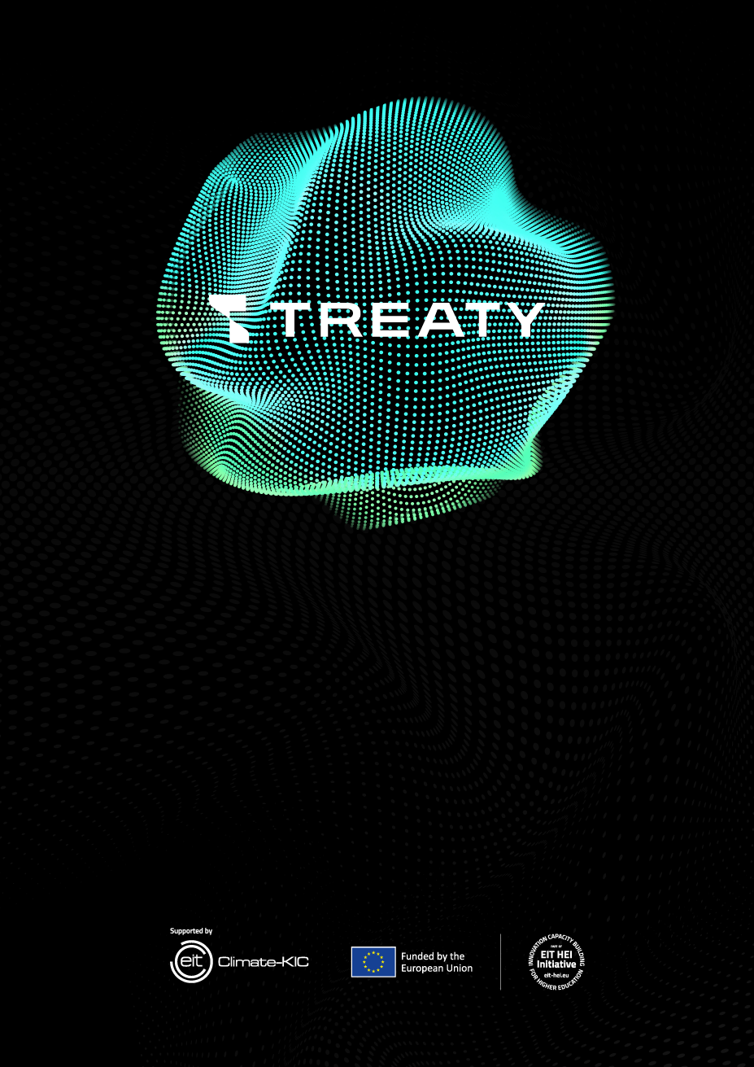
Course Information
Title: 3D visualization, reconstruction and urban design
Instructor(s): Volodymyr Nazarenko
ECTS credits: 2
Course structure: | 60 hours
Lecture classes | 10 hours
Laboratory classes | 10 hours

Mode of delivery: hybrid

Course Summary
The course introduces deep technologies and tools for sustainable urban development in the context of higher education. Participants will master modern approaches to the creation of web/mobile/cloud services (including low-code/no-code), tools for 3D visualization and digital reconstruction of urban spaces (VR/AR), the principles of building digital twins for infrastructure and cities, as well as design thinking methodology for creating innovative solutions. Special emphasis is placed on security, data privacy, ethics, and the impact of decisions on sustainable development.

Course Participants
The course is open to:
- 2-4 year students of bachelor's, master's, and postgraduate students of the faculties of IT, architecture/urban studies, design, economics/management;
- academic and administrative staff of higher education institutions;
- specialists of city departments, utilities, IT companies, urban planning and consulting bureaus.
Prerequisites are preferred: basic digital literacy; basic programming/scripting basics or experience in 3D/CAD/visualization (optional).

Learning Outcomes
[Enter below the learning outcomes of the course. Please Include learning outcomes referring to both knowledge and skills (and attitudes, if applicable), using appropriate verbs, making sure they are measurable. Examples of verbs referring to knowledge: identify, define, list, name, recognize, describe, etc. Examples of verbs referring to skills: apply, produce, design, demonstrate, employ, operate, use, calculate, formulate etc.]
Upon completion of the course, participants will be able to:
- Describe modern architectures and stacks for web/mobile/cloud applications, including low-code/no-code approaches.
- Design and prototype the service, taking into account the needs of users and the limitations of the environment.
- Create basic 3D scenes and visualize urban spaces; apply VR/AR to communicate solutions.
- Build a simplified digital twin of an object/district based on open data and sensory sources.
- Explain the privacy and security risks for digital twins; perform basic threat modeling.
- Apply Privacy/Security-by-Design principles and relevant controls (e.g., at the process and data level).
- Use design thinking - interviews, formulation of HMW tasks, creation and testing of prototypes.
- Prepare visual communication materials (storytelling, moodboards, demo videos) for stakeholders.
- Assess the sustainability and impact of decisions (environmental, social, economic dimensions; urban sustainability indicators).
- Collaborate in a multidisciplinary team: versioning, documentation, and final presentation.

Assessment
In order for each participant to complete successfully the course and be awarded the corresponding ECTS credits, they must pass the course assessment. The outcome of the assessment can be either Pass or Fail.
The assessment format is Pass/Fail. To enroll in 2 ECTS, you must submit all mandatory papers and score≥60%.

Assessment methods [Please choose one or more assessment methods; if there is more than one, please write in brackets the percentage distribution of each assessment method. Also, include a short description of the assessment method, such as: topic, length (word count), formatting, content, structure, time of submission]

- Team project - 50% Prototype/demo of a digital solution for the city + repository/artifacts; short technical description (2000–2500 words). The deadline is 1 week after the 4th session.
- Oral presentation/demonstration - 20% 10 minutes of presentation + 5 minutes of Q&A; clarity, validity, and visualization are evaluated.
- Online quiz - 15% 20(25) questions after the 2nd session (open window 24 hours).
- Course reflection - 15% 700–900 words with a focus on privacy, security, and sustainability of the proposed solution.

The link between learning objectives and assessment criteria can be seen below. [Here each learning outcome mentioned above must be matched with the corresponding assessment method, which can be in addition to the ones mentioned above, e.g. in-class exercises, contribution to round table discussion, etc.].
Learning outcomes | Assessment examples
- Describe modern architectures and stacks for web/mobile/cloud applications, including low-code/no-code approaches. | Online quiz on architectures and cloud principles; in-class discussion on practical frameworks; technical section in the team project documentation.
- Design and prototype a service taking into account user needs and environmental constraints. | Team project - prototype development and usability testing; peer review session with design critique; mentor feedback logs.
- Create basic 3D scenes and visualize urban spaces; apply interactive systems to communicate solutions. | Project - creation of a 3D scene or walkthrough; presentation demo to peers; reflective log on software tools used.
- Build a simplified digital twin of an object/district based on open data and sensory sources. | Project - code demonstration or system diagrams prototype; short oral presentation during the 4th session.
- Use design thinking (interviews, HMW tasks, prototyping, testing). | Team project - demonstration of design-thinking stages; in-class exercise on ideation and iteration; mentor evaluation of process documentation.
- Prepare visual communication materials (storytelling, moodboards, demo videos) for stakeholders. | Presentation with visual storytelling; submission of moodboard or storyboard; peer feedback session assessing clarity and creativity.

Mentoring
[Mentoring should also be provided to course participants. Please mention here ways in which mentoring will be offered. For instance: “In the context of the course, participants will receive one-to-one mentoring in carrying out their assignment/project or acquiring hands-on experience in…”]
- 1:1 + 1 team consultation - minimum 2 hours per team during the course.
- Design crit sessions: intermediate prototype reviews with step-by-step feedback.
- Online support - channel in Discord + asynchronous responses via email.
- Career advice - ways to implement solutions in urban projects/startups.

Bibliography
[Please provide of a list of bibliography and useful resources]
- Cross, N. Design Thinking: Understanding How Designers Think and Work.
- Stanford d.school. Design Thinking Bootleg (Teaching Cards).
- Tao, F. et al. Digital Twin Driven Smart Manufacturing.
- Lynch, K. The Image of the City.
- NIST. Privacy Framework: A Tool for Improving Privacy through Enterprise Risk Management; NIST SP 80053 (Safety Controls Accents).
- ISO/IEC 27001 (information security); ISO 37120/37123 (Urban and Urban Resilience Indicators).
- Documentation: Blender, Unity/Unreal Engine (3D/VR), prototyping tools (Figma, Framer, Power Apps/AppSheet).
- Selected scientific articles and case studies will be provided during lectures.

Other Important Information

Course evaluation: Upon successful completion of the course, participants are required to fill in the course evaluation questionnaire.

Certificate: Upon successful completion of the course, participants will be issued a certificate of achievement provided by The Cyprus Institute and EIT Climate KIC.

Plagiarism: CyI has explicit rules concerning academic dishonesty including plagiarism. Course participants are reminded that all work submitted as part of the requirements for any examination (including coursework) of CyI must be expressed in their own words and incorporated in their own ideas and judgements.

Course Timetable
Session | Date and Time | Instructor | Venue
1st | October 6th, 15.10-16.30 | Volodymyr Nazarenko | Auditorium 206, Campus 15
2nd | October th, 15.10-16.30 | Volodymyr Nazarenko | Auditorium 206, Campus 15
3rd | October 8th, 15.10-16.30 | Volodymyr Nazarenko | Auditorium 206, Campus 15
4th | October 9th, 15.10-16.30 | Volodymyr Nazarenko | Auditorium 206, Campus 15
5th | October 10th, 15.10-16.30 | Volodymyr Nazarenko | Auditorium 206, Campus 15
6th | October 13th, 15.10-16.30 | Volodymyr Nazarenko | Auditorium 206, Campus 15
7th | October 14th, 15.10-16.30 | Volodymyr Nazarenko | Auditorium 206, Campus 15
8th | October 15th, 15.10-16.30 | Volodymyr Nazarenko | Auditorium 206, Campus 15
9th | October 16th, 15.10-16.30 | Volodymyr Nazarenko | Auditorium 206, Campus 15
10th | October 17th, 15.10-16.30 | Volodymyr Nazarenko | Auditorium 206, Campus 15

Contact Details of Instructor(s)
Name | Email | Telephone number
Volodymyr Nazarenko | volodnz@nubip.edu.ua | +380661260476



