

Course Handbook
Digital Twins and Video Games - Data Security and Privacy Issues
Instructor: Volodymyr Nazarenko

Empowering European Universities to Lead Deep Tech Innovation in Sustainable Energy & Clean Technologies

Contents
Course Information 3
Course Summary 3
Learning Outcomes 4
Assessment 4
Mentoring 5
Bibliography 5
Other Important Information 5
Course Timetable 6
Contact Details of Instructor(s) 7

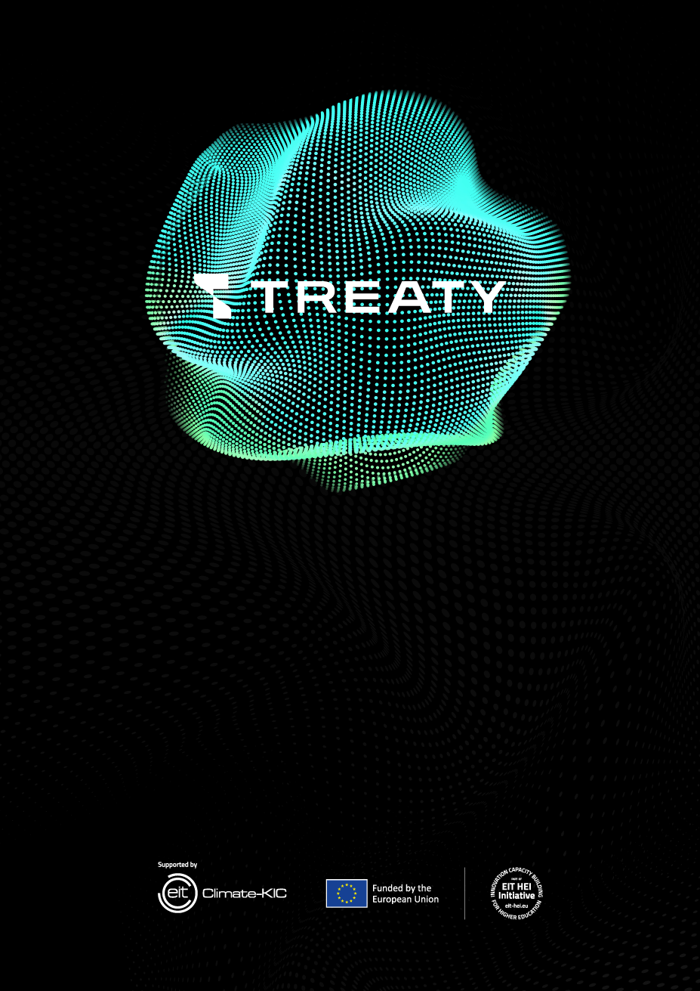
Course Information
Title: Digital Twins and Video Games - Data Security and Privacy Issues
Instructor(s): Volodymyr Nazarenko
ECTS credits: 2
Course structure: | 60 hours
Lecture classes | 10 hours
Laboratory classes | 10 hours

Mode of delivery: hybrid

Course Summary
This course examines how digital twins (DTs) and video game technologies (game engines, telemetry, multiplayer systems) intersect - and how data security and privacy must be built into these systems by design. Participants explore architectures, data pipelines, threat modeling, privacy‑by‑design, secure configuration, and ethical/legal considerations, then apply them in hands‑on labs using visualization and/or game‑engine tooling. The emphasis is on practical controls and communication of risk to stakeholders via dashboards and demos.

Course Participants
The course is open to:
- 2-4 year students of bachelor's, master's, and postgraduate students of the faculties of IT, architecture/urban studies, design, economics/management;
- academic/administrative staff in IT, design/visualization, architecture/urban systems, and related disciplines.
Prerequisites are preferred: basic digital literacy; basic programming/scripting basics or experience in 3D/game design/visualization (optional).

Learning Outcomes
[Enter below the learning outcomes of the course. Please Include learning outcomes referring to both knowledge and skills (and attitudes, if applicable), using appropriate verbs, making sure they are measurable. Examples of verbs referring to knowledge: identify, define, list, name, recognize, describe, etc. Examples of verbs referring to skills: apply, produce, design, demonstrate, employ, operate, use, calculate, formulate etc.]
Upon completion of the course, participants will be able to:
- Differentiate core architectures of digital twins and game/simulation platforms; identify their security/privacy implications.
- Design a minimal data/telemetry pipeline (events, time series, storage, analytics) for DT/game scenarios with privacy constraints.
- Prototype a basic DT scene or playable simulation connecting engine tooling with mock/sensor data.
- Perform threat modeling for DT/game platforms (attack surface, abuse/cheat vectors, API risks) and prioritize mitigations.
- Apply privacy‑by‑design (data minimization, pseudonymization/anonymization, retention) to DT/game data.
- Implement baseline security controls (identity/access, secure configuration, logging/monitoring, anti‑tamper basics).
- Evaluate legal/ethical issues in DT/games (consent, transparency, user safety) and formulate policy‑aligned practices.
- Produce a concise Security & Privacy Plan (DPIA‑style outline) for a prototype.
- Visualize and communicate security/privacy risks in dashboards/storyboards for technical and non‑technical stakeholders.
- Collaborate effectively to deliver a security‑augmented prototype and present findings.

Assessment
In order for each participant to complete the course successfully and be awarded the corresponding ECTS credits, they must pass the course assessment. The outcome of the assessment can be either Pass or Fail.
The assessment format is Pass/Fail. To enroll in 2 ECTS, you must submit all mandatory papers and score≥60%.

Assessment methods [Please choose one or more assessment methods; if there is more than one, please write in brackets the percentage distribution of each assessment method. Also, include a short description of the assessment method, such as: topic, length (word count), formatting, content, structure, time of submission]

- Team project (50%) - Prototype of a DT/game‑based scenario with security/privacy controls; repo/artifacts and short technical/security note (2000–2500 words).
- Oral presentation (20%) - 10‑minute demo and 5‑minute Q&A; clarity of risks/mitigations and visual communication.
- Online quiz (15%) - 20–25 questions on DT/game architectures, threat modeling, privacy/security controls.
- Course reflection (15%) - 700-900 words on trade‑offs (utility vs. privacy/security) for the chosen prototype.

The link between learning objectives and assessment criteria can be seen below. [Here each learning outcome mentioned above must be matched with the corresponding assessment method, which can be in addition to the ones mentioned above, e.g. in-class exercises, contribution to round table discussion, etc.].
Learning outcomes | Assessment examples
- Differentiate core architectures of digital twins and game/simulation platforms; identify their security and privacy implications. | Online quiz; short in-class diagnostic exercise; architectural section in project documentation.
- Design a minimal data/telemetry pipeline for digital-twin or game scenarios, considering privacy constraints. | Project: pipeline diagram or code prototype; mentor review of data flow and data-minimization principles.
- Prototype a basic digital-twin scene or playable simulation integrating real or simulated sensor data. | Laboratory demo; creation of a digital-twin or simulation scene; short presentation to peers.
- Visualize and communicate risks in dashboards or storyboards for both technical and non-technical audiences. | Presentation including a visual risk dashboard or storyboard; peer and instructor review.
- Collaborate effectively in a multidisciplinary team to deliver and present a secure prototype. | Team project evaluation; assessment of collaboration and role distribution during presentation.
- Prepare visual communication materials (storytelling, moodboards, demo videos) for stakeholders. | Presentation with visual storytelling; submission of moodboard or storyboard; peer feedback session assessing clarity and creativity.

Mentoring
[Mentoring should also be provided to course participants. Please mention here ways in which mentoring will be offered. For instance: “In the context of the course, participants will receive one-to-one mentoring in carrying out their assignment/project or acquiring hands-on experience in…”]
- 1:1 + 1 team consultation - minimum 2 hours per team during the course.
- Design crit session - intermediate prototype reviews with step-by-step feedback.
- Online support - channel in Discord + asynchronous responses via email.
- Career/impact coaching toward DT/game‑tech projects and applied research.

Bibliography
[Please provide of a list of bibliography and useful resources]
- Cross, N. Design Thinking: Understanding How Designers Think and Work.
- Stanford d.school. Design Thinking Bootleg (Teaching Cards).
- Tao, F. et al. Digital Twin Driven Smart Manufacturing.
- Lynch, K. The Image of the City.
- NIST. Privacy Framework: A Tool for Improving Privacy through Enterprise Risk Management; NIST SP 80053 (Safety Controls Accents).
- ISO/IEC 27001 (information security); ISO 37120/37123 (Urban and Urban Resilience Indicators).
- Documentation: Blender, Unity/Unreal Engine (3D/VR), prototyping tools (Figma, Framer, Power Apps/AppSheet).
- Selected scientific articles and case studies will be provided during lectures.

Other Important Information

Course evaluation: Upon successful completion of the course, participants are required to fill in the course evaluation questionnaire.

Certificate: Upon successful completion of the course, participants will be issued a certificate of achievement provided by The Cyprus Institute and EIT Climate KIC.

Plagiarism: CyI has explicit rules concerning academic dishonesty including plagiarism. Course participants are reminded that all work submitted as part of the requirements for any examination (including coursework) of CyI must be expressed in their own words and incorporated in their own ideas and judgements.

Course Timetable
Session | Date and Time | Instructor | Venue
1st | 15.10, 15:10–16:30 | Volodymyr Nazarenko | Auditorium 206, Campus 15
2nd | 16.10, 15:10–16:30 | Volodymyr Nazarenko | Auditorium 206, Campus 15
3rd | 17.10, 15:10–16:30 | Volodymyr Nazarenko | Auditorium 206, Campus 15
4th | 18.10, 15:10–16:30 | Volodymyr Nazarenko | Auditorium 206, Campus 15
5th | 19.10, 15:10–16:30 | Volodymyr Nazarenko | Auditorium 206, Campus 15
6th | 22.10, 15:10–16:30 | Volodymyr Nazarenko | Auditorium 206, Campus 15
7th | 23.10, 15:10–16:30 | Volodymyr Nazarenko | Auditorium 206, Campus 15
8th | 24.10, 15:10–16:30 | Volodymyr Nazarenko | Auditorium 206, Campus 15
9th | 25.10, 15:10–16:30 | Volodymyr Nazarenko | Auditorium 206, Campus 15
10th | 26.10, 15:10–16:30 | Volodymyr Nazarenko | Auditorium 206, Campus 15

Contact Details of Instructor(s)
Name | Email | Telephone number
Volodymyr Nazarenko | volodnz@nubip.edu.ua | +380661260476

