

Robotic systems in sustainable production technologies
Instructors: Yurii Romasevych, Mykola Korobko

Empowering European Universities to Lead Deep Tech Innovation in Sustainable Energy & Clean Technologies
Course Handbook

Contents
Course Information 3
Course Summary 3
Learning Outcomes 3
Assessment 4
Mentoring 4
Bibliography 4
Other Important Information 5
Course Timetable 5
Contact Details of Instructor(s) 5

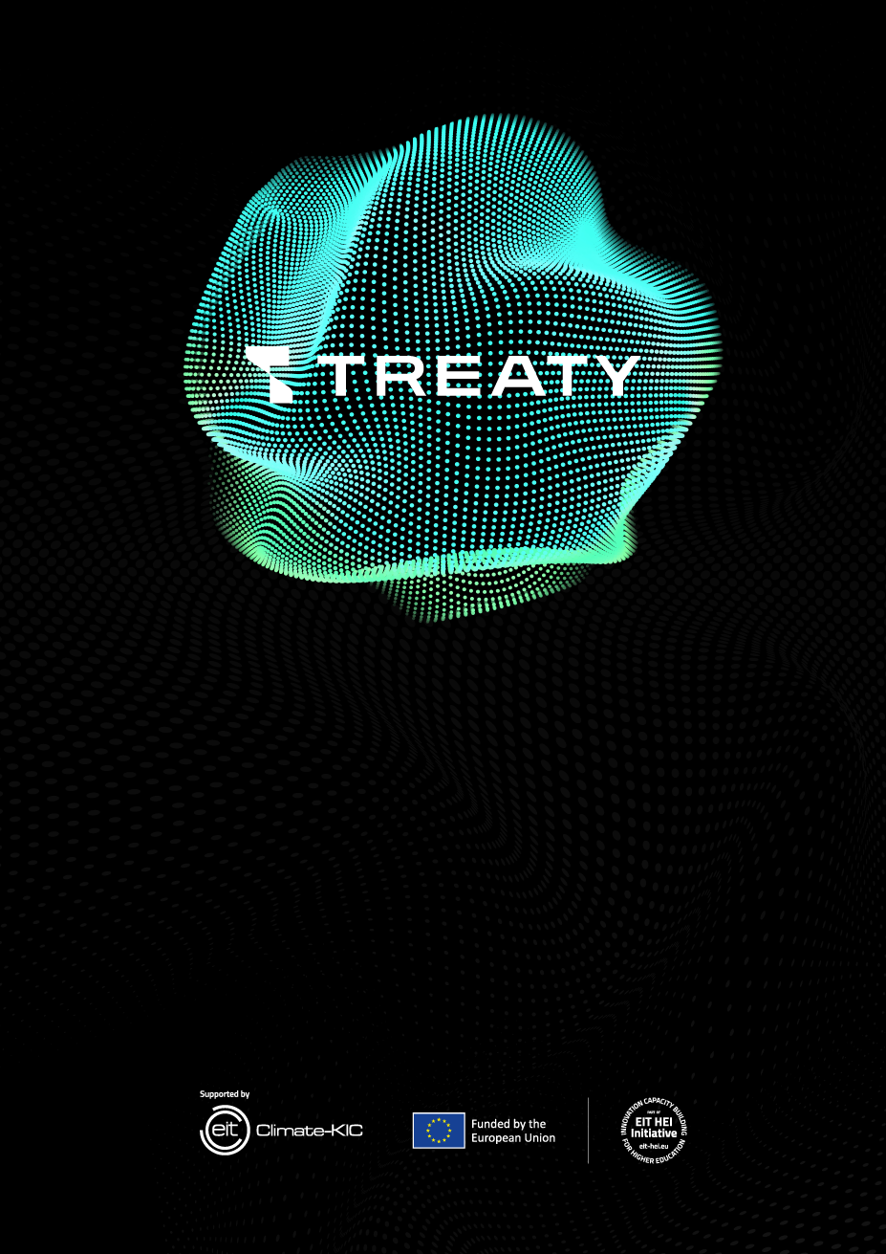
Course Information
Title: Robotic systems in sustainable production technologies
Instructor(s): Yurii Romasevych, Mykola Korobko
ECTS credits: 2
Course structure: | 60 hours
Lecture classes | 10 hours
Laboratory classes | 10 hours
Personal Activities | 40 hours

Mode of delivery: hybrid

Course Summary
This course explores the integration of robotic systems into modern, sustainable manufacturing and production environments. Students will gain knowledge of robotics fundamentals, automation strategies, and sustainable production principles, with a focus on efficiency, resource optimization, and minimizing environmental impact. Key topics include robotic kinematics, control systems, human–robot collaboration, and smart manufacturing.
By the end of the course, students will acquire skills in analyzing, designing, and implementing robotic solutions that support sustainable production goals. They will be able to evaluate trade-offs between productivity and sustainability, apply robotics to green manufacturing processes, and understand the role of digitalization and Industry 4.0 technologies in creating sustainable industrial systems.

Course Participants
This course is designed for a diverse audience of both students and professionals who are interested in the role of robotic systems in sustainable production. Potential participants include:
- students at the bachelor’s, master’s, or doctoral level in engineering, computer science, industrial design, or related fields who wish to broaden their knowledge of robotics and sustainability;
- professionals and practitioners from industry (manufacturing, automation, logistics, energy, etc.) who seek to enhance their skills in applying robotic systems for sustainable production;
- academic and non-academic staff from research institutes, universities, and companies interested in exploring the intersection of robotics, digitalization, and sustainable technologies.

Prerequisites:
- a basic understanding of engineering, production systems, or related technical fields is beneficial;
- no advanced robotics background is required; however, participants should have an interest in automation, sustainable technologies, or innovation in industrial practices;
- the course is open to participants from different disciplinary and professional backgrounds, and a willingness to work in an interdisciplinary environment will be advantageous.

Learning Outcomes
Upon completion of the course, participants will be able to:
- identify and describe fundamental principles of robotic systems and their role in sustainable production technologies;
- recognize and explain the environmental, economic, and social impacts of integrating robotics into manufacturing;
- apply and operate robotic programming and control techniques in simulated or real production tasks;
- design and evaluate robotic solutions to improve energy efficiency, reduce waste, and enhance resource utilization;
- demonstrate the ability to integrate sensors, actuators, and control systems to optimize robotic performance;
- reflect critically on ethical, safety, and societal considerations in deploying robotic technologies.

Assessment
In order for each participant to complete successfully the course and be awarded the corresponding ECTS credits, they must pass the course assessment. The outcome of the assessment can be either Pass or Fail.

Assessment methods
- Exam. 30 different topics are offered to assess the obtained by the participants’ competencies. The content of the exam work includes: topic importance, description of state-of-the-art level of technologies and modern practical trouble killers, tendencies of development. An exam work must include schemes, formulas, plots, text, etc. Number of words > 500. Provided calculations benefit an exam work. The proper format: A4, 14 pt + Times New Roman.

Learning outcomes | Assessment examples
- Identify and describe fundamental principles of robotic systems and their role in sustainable production technologies | Exam + Oral presentation
- Recognize and explain the environmental, economic, and social impacts of integrating robotics into manufacturing | Exam + Oral presentation
- Apply and operate robotic programming and control techniques in simulated or real production tasks | Exam + Report
- Design and evaluate robotic solutions to improve energy efficiency, reduce waste, and enhance resource utilization | Exam + Report
- Demonstrate the ability to integrate sensors, actuators, and control systems to optimize robotic performance | Exam + Oral presentation
- Reflect critically on ethical, safety, and societal considerations in deploying robotic technologies | Exam + Quiz

Mentoring
In the context of the course, participants will receive one-to-one mentoring in carrying out their assignment/project or acquiring hands-on experience in designing, programming, and testing robotic systems for sustainable production tasks. Depending on their background and interests, they may focus on areas such as:
- simulation and modeling of robotic processes for energy and resource efficiency;
- programming and control of industrial or collaborative robots in sustainable production environments;
- integration of digital tools (e.g., sensors, IoT, digital twins) to optimize robotic operations;
- application-driven case studies, such as waste reduction, circular economy approaches, or green logistics.
This mentoring component ensures that each participant develops practical competencies while tailoring the learning outcomes to their individual professional or academic goals.

Bibliography
- Handbook of Intelligent and Sustainable Manufacturing: Tools, Principles, and Strategies. Kumar, A., Parveen, Liu, Y., & Kumar, R. (Eds.). CRC Press, 2024.
- Sustainable Automated Production Systems: Industry 4.0 Models and Techniques. Fazlollahtabar H. CRC Press, 2024.
- Digital Technologies for Sustainable Manufacturing. (Routledge, editors). CRC Press, 2025
- Artificial Intelligence and Robotics in Manufacturing: A Sustainable Future. Edited by Ankit D. Oza, Hreetabh Kishore, Ankit Sharma, Atul Babbar. CRC Press, 2025
- Controls and Robotics for Sustainable Manufacturing, in Encyclopedia of Sustainable Technologies, 2nd edition. I. Kovalenko, H. Li, Y. Li, Harnessing. Elsevier, 2024.
- A Guide to Human-Robot Collaboration in Manufacturing” (white paper, MTC, UK, 2024). URL: https://www.the-mtc.org/guide-human-robot-collaboration-manufacturing

Other Important Information

Course evaluation: Upon successful completion of the course, participants are required to fill in the course evaluation questionnaire.

Certificate: Upon successful completion of the course, participants will be issued a certificate of achievement provided by The Cyprus Institute and EIT Climate KIC.

Plagiarism: CyI has explicit rules concerning academic dishonesty including plagiarism. Course participants are reminded that all work submitted as part of the requirements for any examination (including coursework) of CyI must be expressed in their own words and incorporated in their own ideas and judgements.

Course Timetable
Session | Date and Time | Instructor | Venue
1st | October 6th, 16.50-18.10 | Yurii Romasevych | Auditorium 357, building 11
2nd | October 7th, 16.50-18.10 | Yurii Romasevych | Auditorium 357, building 11
3rd | October 8th, 16.50-18.10 | Yurii Romasevych | Auditorium 357, building 11
4th | October 9th, 16.50-18.10 | Yurii Romasevych | Auditorium 357, building 11
5th | October 10th, 16.50-18.10 | Yurii Romasevych | Auditorium 357, building 11
6th | October 13th, 16.50-18.10 | Mykola Korobko | Auditorium 358, building 11
7th | October 14th, 16.50-18.10 | Mykola Korobko | Auditorium 358, building 11
8th | October 15th, 16.50-18.10 | Mykola Korobko | Auditorium 358, building 11
9th | October 16th, 16.50-18.10 | Mykola Korobko | Auditorium 358, building 11
10th | October 17th, 16.50-18.10 | Mykola Korobko | Auditorium 358, building 11

Contact Details of Instructor(s)
Name | Email | Telephone number
Yurii Romasevych | romasevych@nubip.edu.ua | +380681023164
Mykola Korobko | korobko_mm@nubip.edu.ua | +380672339828



