UDC 62-192(75)

INCREASING THE LEVEL OF RELIABILITY OF AGRICULTURAL MACHINERY

Boltianska N.¹, Boltianskyi О.¹, Syrotyuk S.²
¹Dmytro Motornyi Tavria State Agrotechnological University, Melitopol, Ukraine
²Lviv National Agrarian University, Lviv, Ukraine

One of the determining factors in the competitiveness of agricultural machinery is reliability. Its importance has increased especially with the increase in the unit capacity of power facilities and their operating speeds, the use of wide-cut units and combined machines.
Manufacturers achieve an increase in the reliability of tractors and agricultural machines due to such factors [1–3].
1) Improving design methods using computer systems, testing the designs of various units and parts at the design stage, checking their reliability before the start of production.
2) The use in the designs of machines of a sufficiently well-developed highly reliable element base.
3) the use of new high-quality structural materials for the manufacture of parts, assemblies and basic elements of machines.
4) Improvement of production technologies and quality control of materials, components and manufacturing of machines at all stages of production.
Agricultural engineering plants and their subcontractors are equipped with modern equipment and highly qualified personnel. They have developed and are implementing a set of measures aimed at ensuring the high quality of products. One of the most important measures is comprehensive control. It begins with checking raw materials, blanks of parts and assemblies coming from partners. The main element of the high quality assurance system is the careful monitoring of compliance with technological regulations, the condition of equipment and tools, and the exact observance of technical standards at all stages of production.
Parts manufactured at the enterprise itself are tested on high-precision equipment equipped with computers. The received statistical data are processed and analyzed. According to the results of the analysis, appropriate measures are taken, if necessary. The quality of surface treatment is subject to verification. After heat treatment, the quality of hardening of shafts and gears is checked by non-destructive testing methods and devices for detecting cracks with ultrasound and other methods. Each batch of cast parts is selectively checked for dimensional and coordinate accuracy. The equipment on which parts are produced is also subjected to computer control. On special stands, they check transmissions as a whole, brakes, power take-off shafts (GDP), differential mechanism, electronic control system for attachments. Such a control system provides firms with the ability to guarantee long-term operation of the machine without failure. John Deere, Case-IH, Ford, Massey Ferguson and others have brought the engine life to 12,000 hours. MTBF for many brands of tractors is 1000 hours or more, and for combine harvesters more than 100 hours. As one of the features of the development of agricultural engineering, it is worth noting the significant amount of investment in development work, which ensures high rates of introduction of effective design and technological solutions into production. According to John Deere, its development costs are more than $2 million a day [4,5].
An analysis of the designs of agricultural machinery from leading firms indicates that they widely use automation tools, electronics and computers.
Achievements in the electronics and computer technology industries have been applied in all groups of machines that are used in agriculture: tractors, tillage and sowing machines, sprayers, harvesting equipment. In the designs of agricultural machines, automation tools perform different functions (Fig. 1).

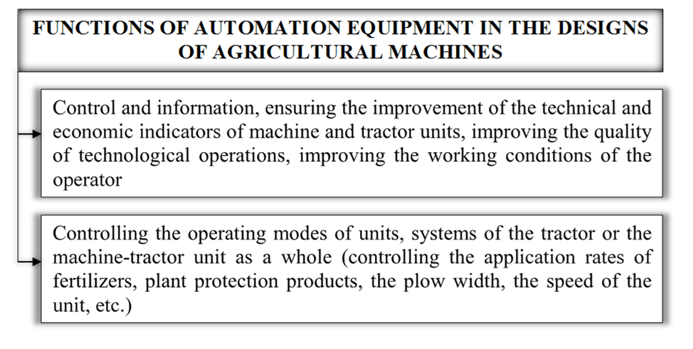
Figure 1. Functions of automation equipment in the designs of agricultural machines

Improving the efficiency of work to ensure the mechanical reliability of agricultural machinery requires the use of a common methodology for conducting accelerated tests, modeling the patterns of occurrence of mechanical failures and improving methods for predicting and ensuring the reliability of the resources of the determining elements. The construction of such a methodology includes the following steps [6,7]:
- analysis of the main types and generalization of the patterns of occurrence of mechanical failures of machines and means of mechanization of agricultural production, modern methods of testing for reliability, forecasting models and methods for ensuring the mechanical reliability of agricultural machinery;
- development and justification of test methods that provide accelerated performance assessments with prediction of mechanical reliability indicators of resource-determining elements;
- improvement of the reliability monitoring system and methods of applied statistical analysis of information adapted to the conditions of testing and operation of mobile agricultural machinery;
- creation of general methods for constructing probabilistic models of mechanical reliability that correspond to the patterns of failures of machinery and equipment in agricultural production;
– development of an inversion method of analysis and determination of equivalent loads on the elements of agricultural machines using operational information;
- development of methods for predicting reliability and substantiation of measures to prevent sudden mechanical failures of elements and systems of agricultural machinery;
- improvement of methods for predicting and providing indicators of tedious durability of elements of agricultural machines operating under multi-mode load conditions. The presence of a common methodology for ensuring mechanical reliability lays the foundation for the formation and effective functioning of an integrated information and methodological system for modeling, predicting and ensuring the mechanical reliability of machines and means of mechanization of agricultural production. The final products of such a system can be nationwide and sectoral regulations of various levels and purposes, from standards and guiding regulations to manufacturing specifications. In modern conditions of a significant loss of experience accumulated in the past and insufficient qualifications of engineering personnel, this path should contribute to the process of reviving mechanical engineering, ensuring an appropriate level of quality and competitiveness of products.
Among the components of the methodology for ensuring the mechanical reliability of machines, we note the importance of developing and improving test methods that allow us to accelerate - experimentally evaluate the reliability indicators of prototypes of the product. In many cases, accelerated tests carried out prior to the start of mass production make it possible to refine (prove) the design and technology, ensuring the level of reliability indicators specified by the standards. In many ways, this makes it possible to compensate for the lack of experience and the level of scientific and theoretical substantiation of technical solutions in the design.
The method of accelerated tests in limiting combined modes, the theoretical justification makes it possible to predict the resource indicators of mechanical reliability in case of gradual failures. A necessary condition for such tests is a preliminary analysis of the operational modes of use of the product and the detection of those that are characterized by the highest intensity of damage accumulation. This is possible only if there is an appropriate reliability monitoring system that emphasizes the importance of an integrated approach to the problem of its provision. After the detection of an extreme damaging mode, it is reproduced during tests as an accelerator of the combined mode component. The remaining spectra of operating modes form the second component of the complementary test mode. Forming several combinations from two components and reproducing them during tests, we get the possibility of predicting the life indicators of mechanical reliability based on the test results.
In addition to experimental methods, when creating reliable equipment, it is important to qualitatively use the stage of its design, using modern methods of theoretical analysis of structures and computerized numerical methods to determine the stress-strain state of elements. But the experience of implementing these methods indicates that the probable prediction of mechanical reliability in many cases is limited by the impossibility of obtaining information about the actual load of the element under operating conditions during the design.
Therefore, there is a certain contradiction between the perfection of theoretical methods for analyzing the stress-strain state and their computer implementation and the uncertainty of the design characteristics of the operational load.
Forecasting the resource characteristics of durability at the design stage requires the ability to make a forecast for the entire distribution of the resource of the designed object. The complexity of the practical solution of this problem primarily lies in the fact that in order to predict the full distribution of the resource, it is necessary to have information about the workload of the object not only in several typical modes of its use, but it is necessary to generalize the statistical dispersion of real loads and other factors over all options for the possible communication of modes.
A wide range of climatic conditions in which mobile agricultural machinery operates has a significant impact on the distribution of durability of many machine elements. The possibility of predicting the distribution of durability is also affected by the statistical dispersion of the features of resistance to the destruction of materials under the operating conditions of the object.
References
1. Скляр О. Г., Болтянська Н. І. Технології наукових досліджень: підручник. Мелітополь: ФОП Однорог Т.В., 2022. 682 с.
2. Непарко Т. А. Технічні засоби для механізації технологічних процесів на тваринницьких фермах. Сучасні проблеми землеробської механіки: Збірник тез доповідей XХІI Міжн. наук. конф. Київ. Ніжин, 2021 С. 83-86
3. Komar A. Basic methods of preparation of organic fertilizer from quail manure. Технічне забезпечення інноваційних технологій в агропромисловому комплексі: мат. ІІІ Міжн. наук.-практ. конф. Мелітополь: ТДАТУ, 2021. С. 183-187. URL: http://www.tsatu.edu.ua/tstt/wp-content/uploads/sites/6/komar2021.pdf
4. Zhuravel D., Skliar O., Modeling the reliability of units and units of irrigation systems. Multidisciplinary academic research. Abstracts of І International Scientific and Practical Conference. Amsterdam, Netherlands 2021. Pp. 83-86.
5. Boltianska N., Serebryakova N. Safety measures during operation of biogas plant. OSHAgro – 2021: Збірник тез І Міжн. наук.-практ. конф. Київ: НУБіП, 2021. С. 22-24.
6. Grigorenko S. Technical means for mechanization of technological processes on livestock farms. Theory, practice and science. Abstracts of V International Scientific and Practical Conference. Tokyo, Japan 2021. Pp. 255-257.
7. Skliar O., Neparko T. Increasing the performance of the park of equipment with Telematics. Інформаційні технології в енергетиці та АПК: матеріали Х-ої Міжн. наук.-практ. конф. ЛНАУ, 2021 р. С. 51-54

