
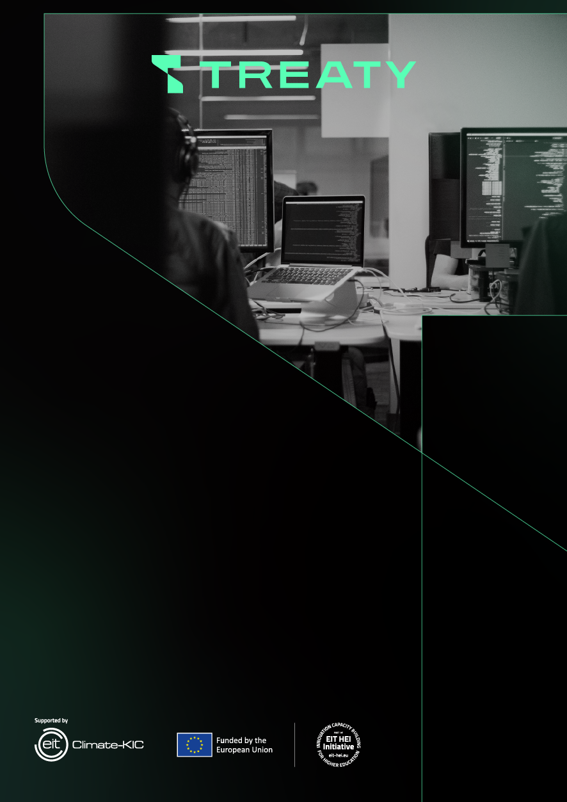
PROGRAM
for non-academic staff training
«Modern mechatronic systems and technologies of artificial intelligence in clean energy»

Certificate – 2.0 ECTS credits (60 hours)
18 teaching hours and 42 non-contact hours

Number of participants: 25 – 30 people

Category of participants: non-academic staff, production staff, experts in renewable energy, scientists, engineers, self-easements, and top managers

Duration: 23.05.2024 – 12.06.2024
Kyiv – 2024
Day, topic, credits, control | Moderator
Day 1 (23.05.2024)  Welcome speech by the head of the Treaty project of the NULES, Professor Gennadii GOLUB  The topic: Modern state of application of mechatronics systems in clean energetics.  Visiting the exhibition of alternative energy objects GREEN EXPO (ACCO International, Kyiv, Beresteyskyi prospect  4 hours (2 lectures and 2 seminars, visiting the exhibition – 4-5 hours) | Prof. Yurii ROMASEVYCH  Assoc. Prof. Mykola KOROBKO
Day 2 (24.05.2024)  2. The topic: "Methodology of design of mechatronic systems in clean energy".  4 hours (2 lectures and 2 seminars) | Prof. Yurii ROMASEVYCH  Assoc. Prof. Mykola KOROBKO
Day 3 (27.05.2024)  3. The topic: "Engineering approaches to the rational selection of components of mechatronic systems".  4 hours (2 lectures and 2 seminars) | Prof. Yurii ROMASEVYCH  Assoc. Prof. Mykola KOROBKO
Day 4 (28.05.2024)  4. The topic: "Approaches to solving clean energy problems by using artificial intelligence technologies".  4 hours (2 lectures and 2 seminars) | Prof. Yurii ROMASEVYCH  Assoc. Prof. Mykola KOROBKO

Day 5 (29.05.2024)  5. The topic: "Classification of artificial neural networks and features of their application in energy problems".  4 hours (2 lectures and 2 seminars) | Prof. Yurii ROMASEVYCH  Assoc. Prof. Mykola KOROBKO
Day 6 (30.05.2024)  6. The topic: "Training paradigms of artificial neural networks, approaches to avoiding their overfitting".  4 hours (2 lectures and 2 seminars) | Prof. Yurii ROMASEVYCH  Assoc. Prof. Mykola KOROBKO
Day 7 (04.06.2024)  7. The topic: "Motion control of mechatronic systems by using neurocontrollers".  4 hours (2 lectures and 2 seminars) | Prof. Yurii ROMASEVYCH  Assoc. Prof. Mykola KOROBKO
Day 8 (05.06.2024)  8. The topic: "Features of the use of fuzzy systems for clean energy facilities (disadvantages, advantages and appropriate areas of application)”.  4 hours (2 lectures and 2 seminars) | Prof. Yurii ROMASEVYCH  Assoc. Prof. Mykola KOROBKO
Day 9 (06.06.2024)  9. The topic: "Synthesis of fuzzy control systems for clean energy facilities”.  4 hours (2 lectures and 2 seminars) | Prof. Yurii ROMASEVYCH  Assoc. Prof. Mykola KOROBKO
Day 10 (12.06.2024)  Summarizing. Presentation of certificates to graduates. | Prof. Yurii ROMASEVYCH





treaty-project.eu

