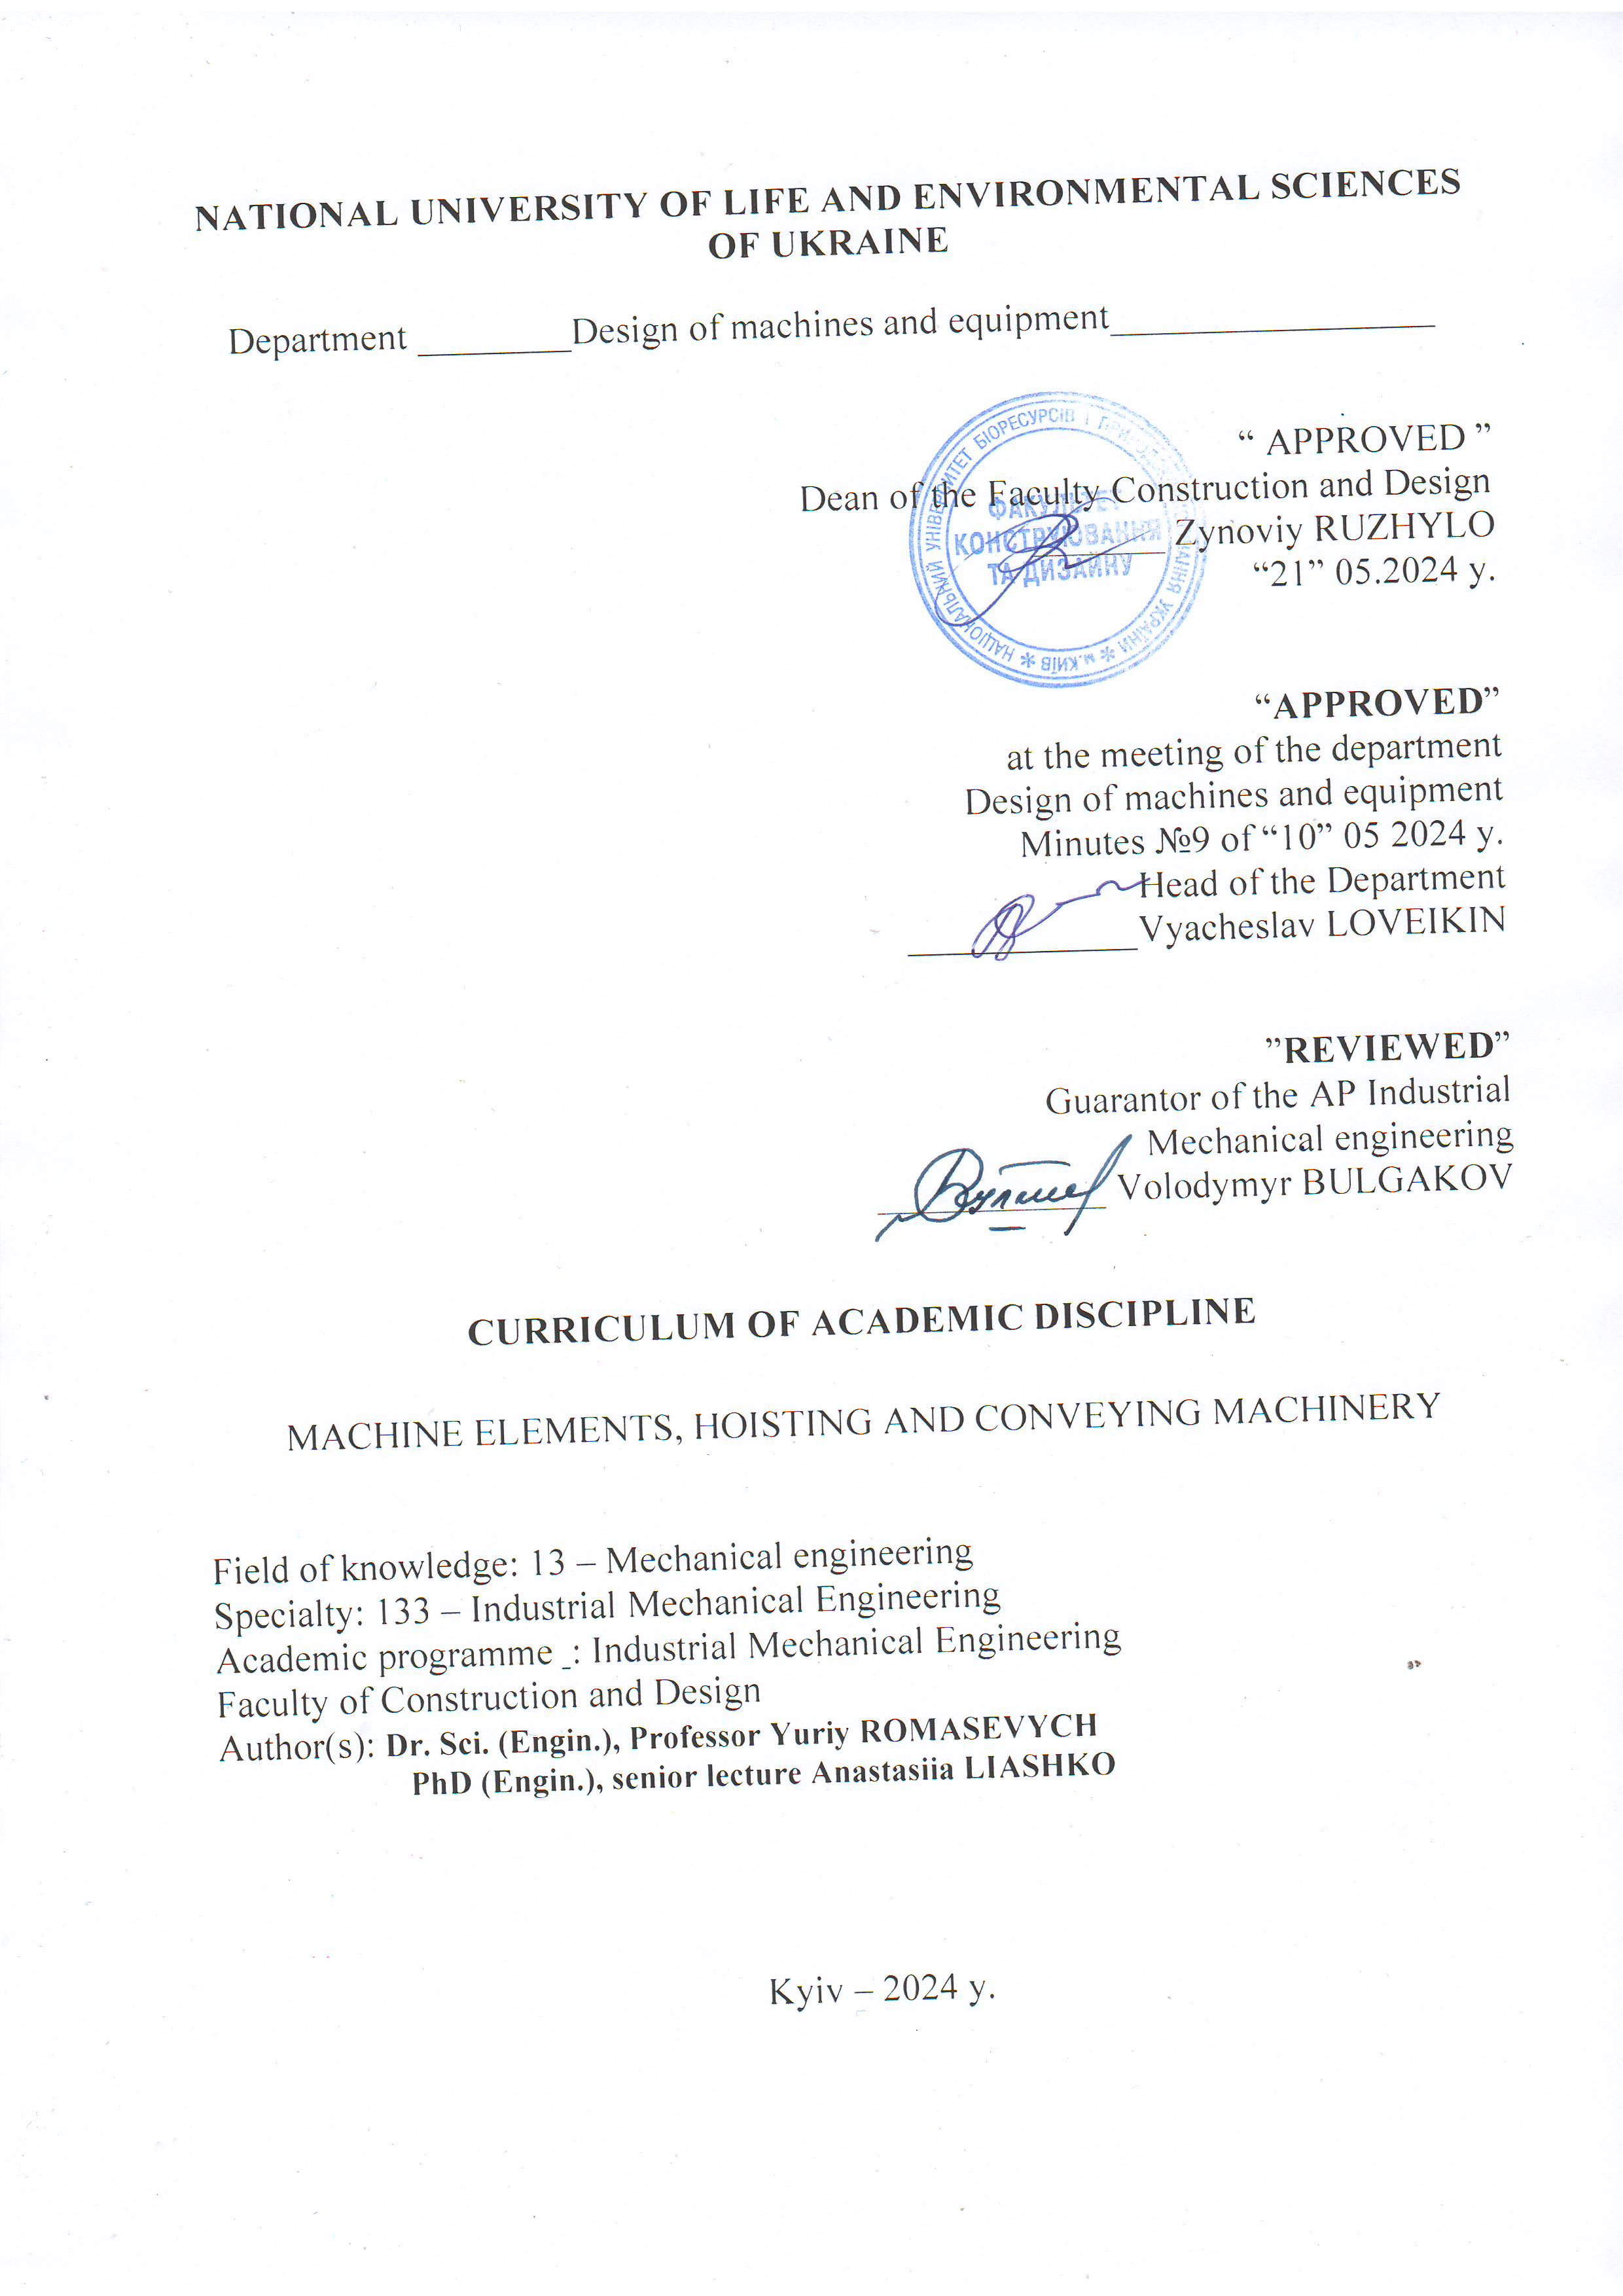
NATIONAL UNIVERSITY OF LIFE AND ENVIRONMENTAL SCIENCES OF UKRAINE

Department ________Design of machines and equipment_________________

“ APPROVED ”
Dean of the Faculty Construction and Design
_______ Zynoviy RUZHYLO
“21” 05.2024 y.

“APPROVED”
at the meeting of the department
Design of machines and equipment
Minutes №9 of “10” 05 2024 y.
Head of the Department
____________Vyacheslav LOVEIKIN

”REVIEWED”
Guarantor of the AP Industrial
Mechanical engineering
____________ Volodymyr BULGAKOV

CURRICULUM OF ACADEMIC DISCIPLINE

MACHINE ELEMENTS, HOISTING AND CONVEYING MACHINERY

Field of knowledge: 13 – Mechanical engineering
Specialty: 133 – Industrial Mechanical Engineering
Academic programme : Industrial Mechanical Engineering
Faculty of Construction and Design
Author(s): Dr. Sci. (Engin.), Professor Yuriy ROMASEVYCH
PhD (Engin.), senior lecture Anastasiia LIASHKO

Kyiv – 2024 y.

Description of the discipline
MACHINE ELEMENTS, HOISTING AND CONVEYING MACHINERY

Academic degree, specialty, academic programme
Academic degree | Bachelor's
Specialty | 133 - Industrial Mechanical Engineering
Academic programme | Industrial Mechanical Engineering
Characteristics of the discipline
Type | Compulsory
Total number of hours | 240
Number of ECTS credits | 8
Number of modules | 6
Course project (work) (if any) | Course project
Form of assessment | Credit, Exam, Exam
Indicators of the discipline for full-time and part-time forms of university study
 | Full-time form of study
Year of study | 3,4
Semester | 5,6,7
Lectures | 75hr.
Practical classes and seminars | - hr.
Laboratory classes | 90hr.
Self-study | 45hr.
Number of hours per week for full-time students | 4 hr.  4 hr  3 hr

- Aim, objectives, competences and expected learning outcomes of the discipline
The aim of discipline is the formation of students’ systematic knowledge: using of structural materials, heat treatment, methods of calculation and design of general purpose parts, the application of modern methods of calculating passive gears, the choice of roller bearings, the assembly of kinematic schemes of actuators of agricultural machines, the use of the method of selecting the standard electric motors, reducers, mechanical couplings.
The objectives of the discipline is as follows: to study the features of the calculation and design of general purpose components: gear gears and flexible couplings, shafts and axles, rolling bearings and sliding bearings, to master the specifics of the design of body parts and frames, to learn to independently design elements of agricultural machines ( parts, assembly units).

Acquisition of competences:
Integral competence (ІC): The ability of a person to solve complex specialized tasks and practical problems in a certain field of professional activity or in the learning process, which involves the application of certain theories and methods of the relevant sciences and is characterized by the complexity and uncertainty of conditions.
General competences (GC): GC 2. Ability to apply knowledge in practical situations.
GC 5.Ability to generate new ideas (creativity).
GC 6.The ability to conduct research at a certain level.
GC 8.The ability to act socially responsibly and consciously.
GC 10.Have skills in using information and communication technologies.
GC 12.The ability to realize one's rights and responsibilities as a member of society, to be aware of the values of a civil (free democratic) society and the need for its sustainable development, the rule of law, the rights and freedoms of a person and a citizen in Ukraine.
GC 13.The ability to preserve and multiply moral, cultural, scientific values and achievements of society based on an understanding of the history and patterns of development of the subject area, its place in the general system of knowledge about nature and society and in the development of society, technology and technologies, to use various types and forms of motor activity for active recreation and leading a healthy lifestyle.
Special (professional) competences (SC): PC 1. Ability to apply typical analytical methods and computer software tools for solving engineering problems of industrial mechanical engineering, effective quantitative methods of mathematics, physics, engineering sciences, as well as appropriate computer software for solving engineering problems of industrial mechanical engineering.
PC 5.Ability to use computerized design systems and specialized application software to solve engineering tasks in the field of mechanical engineering.
PC 6.The ability to evaluate the technical and economic efficiency of typical systems and their components based on the application of analytical methods, analysis of analogues and the use of available data.
PC 7.The ability to make effective decisions regarding the selection of construction materials, equipment, processes and to combine theory and practice to solve an engineering task.
PC 9.The ability to carry out commercial and economic activities in the field of mechanical engineering.
PC 10.The ability to develop plans and projects in the field of mechanical engineering under uncertain conditions, aimed at achieving the goal, taking into account existing limitations, to solve complex problems and practical problems of improving product quality and its control.
Expected Learning Outcomes (ELO): ELO 1. Knowledge and understanding of the basics of technological, fundamental and engineering sciences, which are the basis of industrial mechanical engineering in the relevant field.
ELO 2.Knowledge and understanding of mechanics and mechanical engineering and their development prospects.
ELO 4.Carry out engineering calculations to solve complex problems and practical problems in industrial mechanical engineering.
ELO 7.Prepare production and operate products using automatic life cycle support systems.
ELO 10.To understand the problems of labor protection and legal aspects of engineering activity in industrial mechanical engineering, the skills of forecasting the social and environmental consequences of the implementation of technical tasks.
ELO 11.Communicate freely with the engineering community orally and in writing in national and foreign languages.
ELO 12.Apply means of technical control to evaluate the parameters of objects and processes in industrial mechanical engineering.
ELO 14.Develop machine parts and assemblies using automated design systems.

- Program and structure of the course for:
– complete full-time (part-time) form of study;

Modules  and topics | Number of hours
Modules  and topics | full-time
Modules  and topics | weeks | total | including
Modules  and topics | weeks | total | l | p | lab | ind | s.st
1 | 2 | 3 | 4 | 5 | 6 | 7 | 8
5-th semester

Module 1. Transmissions. Part I.
Theme 1. Introduction: What is Machine Design? | 1-2 | 10 | 4 | - | 4 | - | 2
Theme 2. Transmission Mechanism. Gear. | 3-4 | 10 | 4 | - | 4 | - | 2
Theme 3. Gear Failure | 5-6 | 10 | 4 | - | 4 | - | 2
Theme 4. Involute Spur Gears | 7 | 5 | 2 | - | 2 | - | 1
Total for module 1 | 35 |  | 14 | - | 14 | - | 7
Module 2. Transmission. Part II.

Theme 1. Calculation of spur gear | 8-9 | 10 | 4 | - | 4 | - | 2
Theme 2. Helical Spur Gear | 10-11 | 10 | 4 | - | 4 | - | 2
Theme 3. Bevel Gear | 12-13 | 10 | 4 | - | 4 | - | 2
Theme 4. Worm Gearing | 14-15 | 10 | 4 | - | 4 | - | 2
Total for module 2 | 40 |  | 16 | - | 16 | - | 8
Total for 5-th semester | 75 |  | 30 | - | 30 |  | 15
6-th semester

Module 3. Drives. Shafts and bearings
Theme 1. Chain transmissions | 1-2 | 10 | 4 | - | 4 | - | 2
Theme 2. Belt transmissions. | 3-4 | 10 | 4 | - | 4 | - | 2
Theme 3. Shafts and axles. | 5-6 | 10 | 4 | - | 4 | - | 2
Theme 4. Sliding and rolling bearings. | 7-8 | 10 | 4 | - | 4 | - | 2
Total for module 3 | 40 |  | 16 | - | 16 | - | 8
Module 4. Couplings, springs, designing of reducers

Theme 1. The combination of machine elements. Riveting couplings | 9-10 | 10 | 4 | - | 4 | - | 2
Theme 2. Combining elements with tension | 11-12 | 10 | 4 | - | 4 | - | 2
Theme 3. Slicing joints | 13-14 | 10 | 4 | - | 4 | - | 2
Theme 4. Seals, lubricants and devices | 15 | 5 | 2 | - | 2 | - | 1
Total for module 4 | 35 |  | 14 | - | 14 | - | 7
Total for 6-th semester | 75 |  | 30 | - | 30 | - | 15
7-th semester

Module 5. Conveying machines
Theme 1. Introduction. Characteristics of lifting and conveying machines | 1 | 1 | 1 | - |  | -
Theme 2. Belt conveyors | 1-3 | 12 | 2 | - | 6 | - | 4
Theme 3. Bucket conveyors | 4-5 | 8 | 2 | - | 6 | -
Theme 4. Chain Conveyors | 6 | 1 | 1 | - |  | -
Theme 5. ScrewConveyors | 7-8 | 9 | 1 | - | 4 | - | 4
Total for module 5 | 31 |  | 7 |  | 16 |  | 8
Module 6. Hoisting machines

Theme 1. Overhead cranes | 9-10 | 6 | 2 | - |  | - | 4
Theme 2. Tower cranes and Derricks | 10 | 2 | 2 | - |  | -
Theme 3. Ropes, Blocks-and-Tackles | 11-12 | 8 | 2 | - | 6 | -
Theme 4. Load-Handling Devices | 13-14 | 5 | 1 | - | 4 | -
Theme 5. Hoists and Winches | 14-15 | 8 | 1 | - | 4 |  | 3
Total for module 6 | 29 |  | 8 |  | 14 |  | 7
Total for 7-th semester | 60 |  | 15 |  | 30 |  | 15
Course project | 30 |  | - | - | - | 30 | -
Total hours | 240 |  | 75 |  | 90 | 30 | 45

- Topics of laboratory (practical, seminar) classes

№ | Topic title | Hours
 | Studying the design and determining the basic parameters of a cylindrical gearbox | 4
 | Adjustment of clutches of a closed worm gear | 4
 | Determination of the force of the previous tension of the flat pass | 4
 | Determination of the force of the previous tension of the wedge passive transmission | 4
 | Studying the design and determining the main parameters of the variator | 4
 | Study of design and research of speed variators | 4
 | Investigation of the resonance phenomenon of the rotating shaft | 4
 | Study of the design and determination of the main parameters of the bearings of sliding | 4
 | Determination of friction costs of bearings | 4
 | Research of work of bearing nodes | 4
 | Investigation of friction of bearing rollers | 4
 | Studying the elements of joints | 4
 | Research of safety couplings | 4
 | Investigation of springs “tension – compression” | 4
 | Determination of the volume of oil and lubrication conditions of gear units | 4
 | Belt Conveyor | 6
 | Screw Conveyor | 6
 | Bucket Conveyor | 4
 | Ropes, Block-And-Tackles | 6
 | Telpher | 4
 | Jacks | 4

- Topics of self-study

№ | Topic title | Hours
1 | Kinematic analysis of a mechanical drive | 4
2 | Calculation of opened gears and drives | 4
3 | Selecting couplings | 3
4 | Assembly drawing of subshaft | 5
5 | Selecting bearings | 3
6 | Selecting keys | 2
7 | Calculation of shaft by equivalent moment | 3
8 | Assembly drawing of drive | 6
9 | Determination of the force in the belt (method of bypassing the contour). Calculation of the power of the conveyor drive. | 3
10 | Types of the screws and their operation. Calculation of the power of the conveyor drive. | 4
11 | Calculation of power of a hoist and trolley. Selection of the drive (motor, reducer, couplings) | 4
12 | Hydraulic and screw jacks operation. Force analysis. Selection and calculation. Advantages and drawbacks | 4

- Tools for assessing expected learning outcomes:
  - exam;
  - credit;
  - module tests;
  - graphic design works;
  - presentation of laboratory and practical works;
  - other types.

- Teaching methods:
  - verbal method (lecture, discussion, interview, etc.);
  - practical method (laboratory classes);
  - visual method (illustration, demonstration);
  - processing learning resources (note-taking, summarising, reviewing, writing an abstract);
  - video method (remote, multimedia, web-based, etc.);
  - self-study (completing assignments);
  - individual research work;

- Assessment methods:
  - exam;
  - credit;
  - oral or written assessment;
  - module tests;
  - presentation of laboratory and practical works;
  - presentations at academic events

- Distribution of points received by students
The assessment of students’ knowledge and skills is conducted by means of a 100-point scale and is converted into national grades according to Table 1 of the current Exam and Credit Regulations at NULES of Ukraine.

Student’s rating, points | National grading of exams and credits
Student’s rating, points | exams | credits
90-100 | excellent | pass
74-89 | good | pass
60-73 | satisfactorily | pass
0-59 | unsatisfactorily | fail

To determine a student’s rating in the discipline RDIS (up to 100 points), the received assessment rating RA (up to 30 points) is added to the academic performance raiting RAP (up to 70 points): RDIS = RAP + RA.

- Teaching and learning aids
  - e-learning course of the discipline (https://elearn.nubip.edu.ua/enrol/index.php?id=759; https://elearn.nubip.edu.ua/course/view.php?id=3461);
  - lectures and presentations (in electronic form);
  - textbooks, manuals, tutorials;
  - guidelines for studying a discipline by full-time and part-time students;

- Recommended sources of information

- Steven R. Schmid, Bernard J. Hamrock, Bo O. Jacobson. Fundamentals of Machine Elements (2nd Edition).2021. 489 p.
- V.B. Bhandari. Design of Machine elements. 2020. 1024 p.
- Robert C. Juvinall and Kurt M. Marshek. Fundamentals of Machine Component Design. 6th edition. 2020. 929 p.
- Robert L. Mott, Edward M. Varvek, Jyhwen Wang. Machine elements in Mechanical Design. 2017. 856 p.
- D.V. Subba Rao. The Belt Conveyor: A Concise Basic Course.1st Edition. 2020. 168 p.
- Ловейкін В. С., Рибалко В. М., Ромасевич Ю. О., Матухно Н. В., Ляшко А. П. Деталі машин. Друге видання. К.: «Компринт». 2020. 736 с.
- Ловейкін В. С., Рибалко В. М., Ляшко А. П., Матухно Н. В. Деталі машин. Частина 1. К.: «Компринт». 2023. 580 с.
- Гайдамака А. В. Деталі машин. Основи теорії та розрахунків: 15 навчальний посібник для студентів машинобудівних спеціальностей усіх форм навчання. Харків : НТУ «ХПІ». 2020. 275 с.
- Яким Р. С. Приводи транспортних машин : навчальнийпосібник [для студентів закладів вищої освіти]. Дрогобич: Редакційно-видавничий відділ Дрогобицького державного педагогічного університету імені Івана Франка, 2020. 240 с
- Жигулін О. А., Махмудов І. І., Жигуліна Н. О. Підйомно-транспортні машини: Навчальний посібник. Ніжин, 2020. 150 с.

