Name Surname
Academic degree, Academic title, position
Work place: identify the organization (e.g., university, department, etc.), City, Country
ORCID ID
email@email.com
Name Surname (for each co-author)
Academic degree, Academic title, position
Work place: identify the organization (e.g., university, department, etc.), City, Country
ORCID ID
email@email.com

TITLE OF THE ARTICLE
Abstract. Abstract should briefly and quite informative summarize main ideas and received research results. The abstract should be at least 1800 characters long, including keywords. As search engines crawl the magazine's content by title, keyword, and annotations, as well they should describe the content of your article. To provide a better search of the content on the network, please avoid too generalized and complex language, use only well-known abbreviations.
Keywords: term 1; term 2; term 3.
1. INTRODUCTION (MANDATORY SECTION)
Format of each structural element is described in the "Requirements for the articles." This instruction is issued in accordance with these requirements and can be used as a template. Please, before you upload the log file, check all the details of the finished manuscript, including the order of authors’ names. Make sure you have the email address of each author and article pages are not numbered.
The problem statement. This part of the article describes the problem, considers a dedicated research in general and its relationship to important scientific and practical tasks.
Analysis of recent studies and publications. In this sub-section should be specified initial works on this problem and relied upon by author. As a result of the analysis of sources, earlier unsolved parts of the general problem highlighted in the article are selected. Referencing is made in accordance with IEEE citation style. The references should be numbered and appear in the order they appear in the text. When referring to a reference in the text of the document, put the number of the reference in square brackets:
- a reference given in square brackets, for example [10];
- comma separated pages [3, p. 35] – 3-d source of 35th page;
- when citing several sources simultaneously, each number must be listed separately, in its own brackets, separated by commas or dashes: [3], [4], [5], [6] or [3] - [6].
The article’s goal. Forming of the purposes of the article (statement of the problem). For example, "... Given this the purpose of the article is to highlight approaches" cloud computing ", which allow to efficiently and cost-effectively building the service-oriented system of education, based on the platform Moodle. ... ".

Depending on the research type the main part of article’s content can consist of the following structural sections (for author decision). If some section(s) are removed other sections, subsections and paragraphs should be sequentially numbered. Please do not change the names of sections.

2. THE THEORETICAL BACKGROUNDS (OPTIONAL SECTION)
This section contains concepts, approaches, principles and main provisions of research. The basic concepts and categories are provided.
3. RESEARCH METHODS (OPTIONAL SECTION)
This section describes the method of preparation and conducting research as well as experimental base of research, participants or investigating facilities. Also the characteristics, criteria, indicators and parameters of assessing are provided. The names and registration numbers of scientific programs and research projects can be provided.
4. THE RESULTS AND DISCUSSION (MANDATORY SECTION)
This section contains an analysis and justification of scientific results. The division into units are recommended.
4.1. Formatting of individual objects
All illustrations, diagrams, software code and tables should be located as far as they are mentioned in the text (not at the end of the article).
4.1.1. Lists
Lists are issued as follows:
- numbered - "1." "1)", "a)", "VI.";
- labeled – "-", "•".
4.1.2. Formulas
Equations and mathematical symbols and letters which denote the variables in the text should be given in bitmap format with at least 150 dpi resolution, without frame and fill. Font-Times New Roman 12pt, centered, numbered – in parentheses to the right.

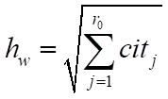 (1)

where cit – the number of citations, r₀ – the largest index number of the series j, such that r_{w} (j) ≤ cit_{j}
4.1.3. The software code
Samples of the software code should be typed by font Courier New, 9 pt. Before and after the code it is necessary to leave a blank line.

def nicedet(M):
s="$\\left|\\begin{array}{ccc} "
for i in range(M.nrows()):
for j in range(M.ncols()):
s=s+" "+latex(M[i,j])
if j!=M.ncols()-1:
s=s+"&"
4.1.4. Figures
Illustrations (photos, drawings, diagrams, graphs, maps, screenshots of the site), tables should be submitted in the article directly after the text where they are mentioned for the first time, or on the next page. All figures should have links in the text. Illustrations are denoted by the word "Figure", numbered consecutively with Arabic numerals, aligned in the center. The names of the illustrations are placed after their numbers. If necessary, the illustrations are supplemented with explanatory data. The name of the drawing is written with a capital letter and must be placed in the middle of the sheet under the illustration, italics. After the name, the point is not put. The quality of the illustrations should ensure their clear reproduction. Illustrations in the article can be black and white or colored and have a single style.
Before and after the drawing, it should be left one blank line.
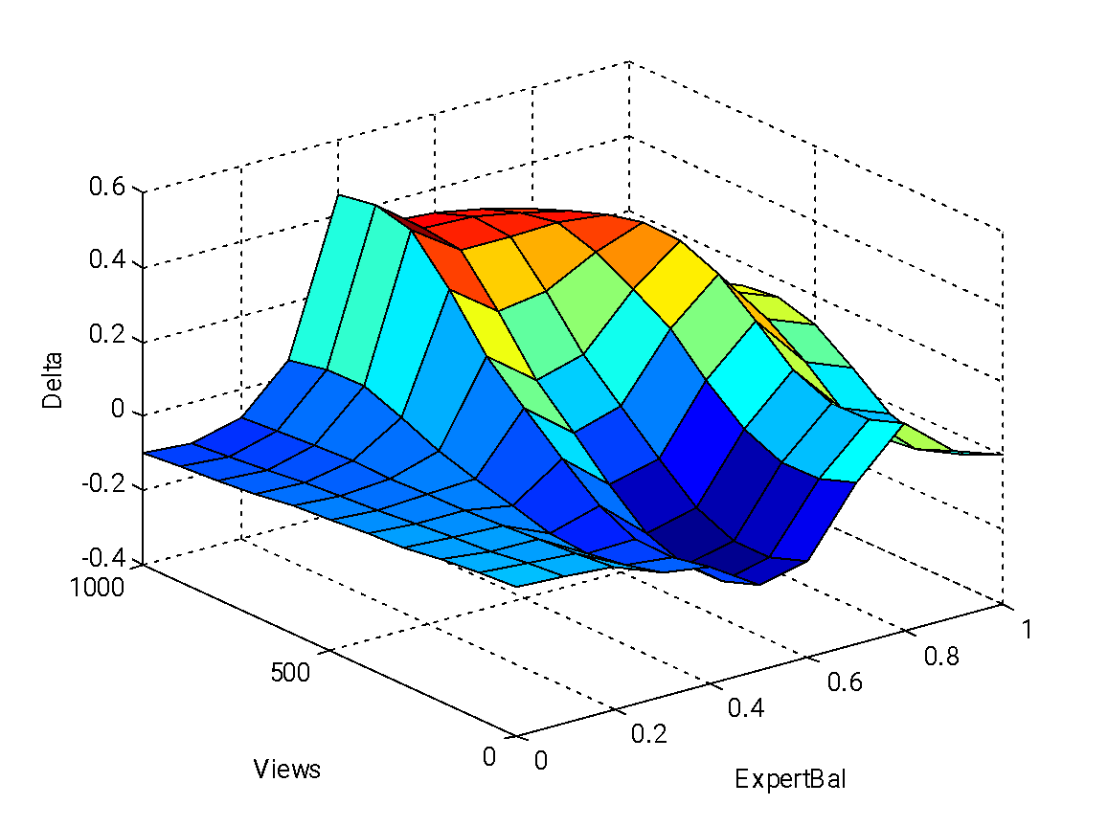

Figure1. Surface of errors of Sugeno type fuzzy systems
4.1.5. Tables
Tables are numbered, centered, without spaces. The word "Table 1", italic, right. Format of table name: centered, bold, position - above the table. After the table it is necessary to leave a blank line.

Table 1
Didactics possibilities of webinar-oriented platforms usage
Didactics tasks | Means of webinar-oriented platform
Presentation of initial information, illustration of teacher’s explanation | - audio and video conferencing  - whiteboard  - electronic bulletin  - joint visit Web sites  - demonstration of the software  - demo presentations and files of various formats
Providing of team interaction | - text chat, audio and video conferencing  - collaboration with the white and documents  - additional virtual rooms for group learning
Evaluation of learning achievements | - tests, interviews with immediate visualization of the results

CONCLUSIONS AND PROSPECTS FOR FURTHER RESEARCH (MANDATORY SECTION)
This section briefly summarizes the results of the research contained in the body.
ACKNOWLEDGEMENT (OPTIONAL SECTION)
In this section, you can specify organizations (academic institutions, universities, departments, sponsorship organizations, etc.), the names of individuals who have contributed to improving the quality of content or provided financial assistance for the research presented in this article.
The article, sections «REFERENCES» and «REFERENCES (TRANSLATED AND TRANSLITERATED)» are made in accordance with the IEEE style.
REFERENCES (TRANSLATED AND TRANSLITERATED)
All in-text citations should be listed in the reference list in Roman script.
The list of used sources is made in accordance with the IEEE style:
- sources are numbered and organized in the list of references in the order they are mentioned in the text, the serial number is indicated in square brackets before the bibliographic description;
- we recommend that the list of used sources should be consisted of not more than 6 items.

More information about IEEE reference style: http://www.citethisforme.com/citation-generator/ieee
Text of the article was accepted by Editorial Team __.__.20__

This work is licensed under Creative Commons Attribution-NonCommercial-ShareAlike 4.0 International License.

